Online Examination Management System
Vector University has developed an online Examination Management System to conduct online assessments. The website looks as shown below.

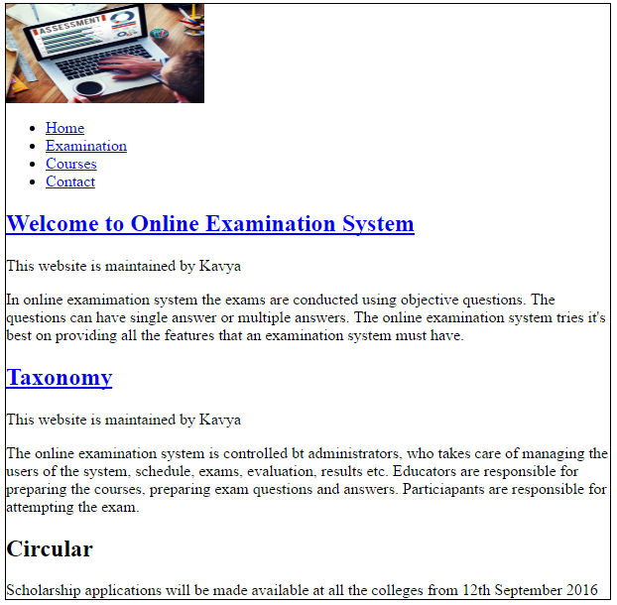

The courses page displays a registration form as shown below
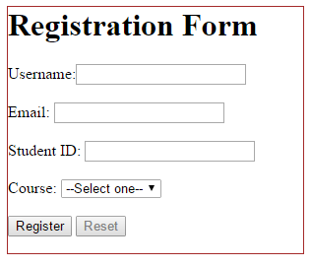
Vector University wants to add CSS to the website. The university wants the webpage to look as shown in Fig 1 and Fig 2.
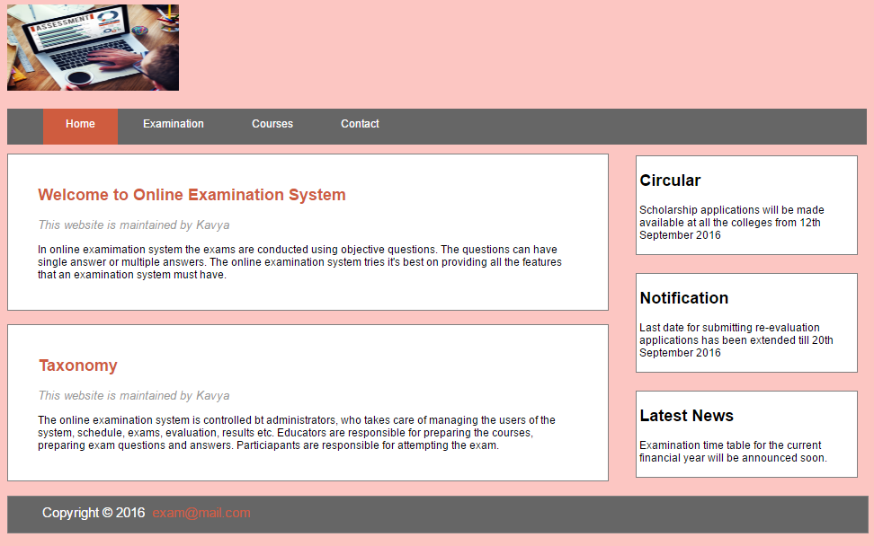
Fig 1
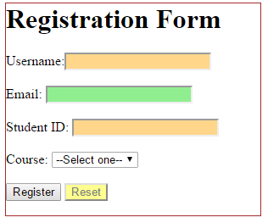

Fig 2
Supplied Files:
images and HTML files
Following is the work you need to accomplish:
Note: Use id selector, class selector, contextual selectors and group the selectors according to the requirement.
- Style the body and the image as shown below.

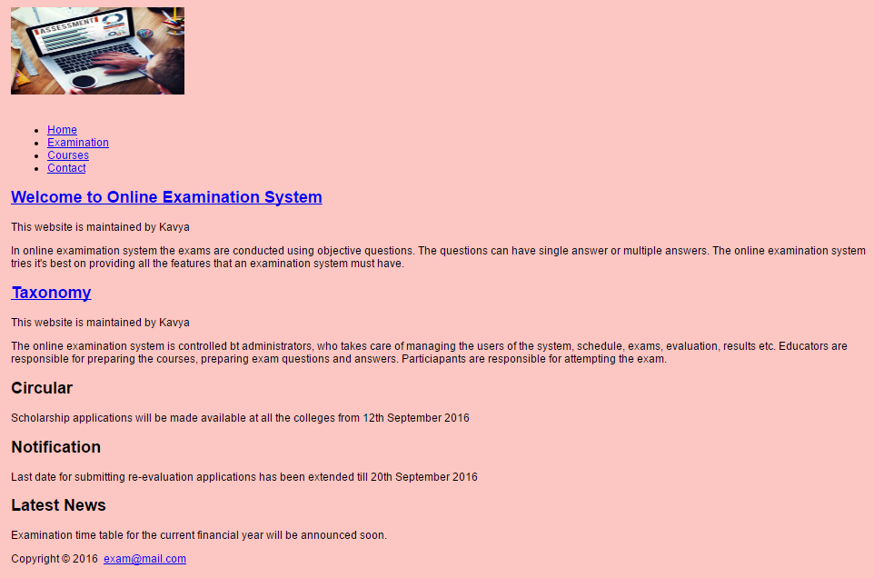
Hint: Use background-image, font, margin, width, height properties
- Style the links as shown below

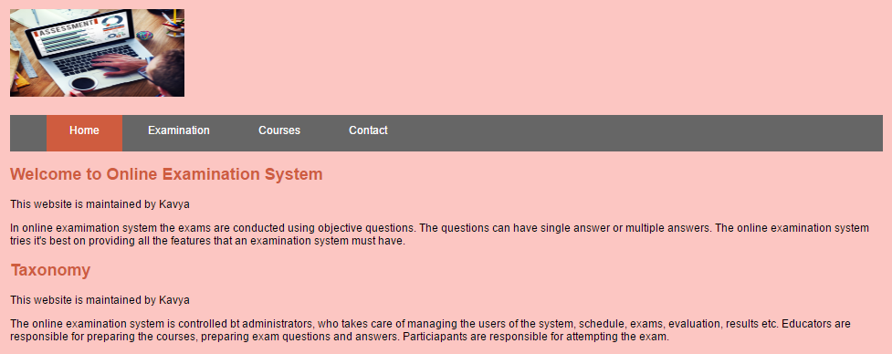
Hint: Use color, padding, height, display, background-color, list-style-type, and margin properties also use link related pseudo-classes.
The regular links and visited links should have grey background-color and white text color. When hovered or active the links should have orange background-color and white text color as shown above.
- Style the content of the webpage as shown below

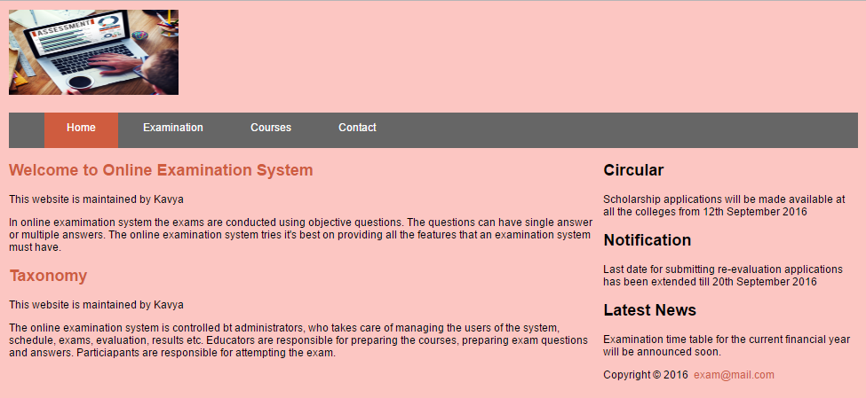
Hint: Use width and float properties
- Style the topContent and bottomContent as shown below
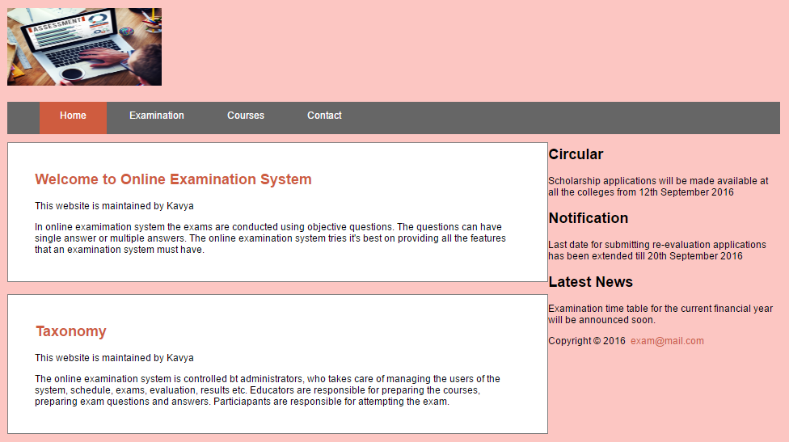
Hint: Use background-color, border, padding, margin properties
- Style the sidebars as shown below
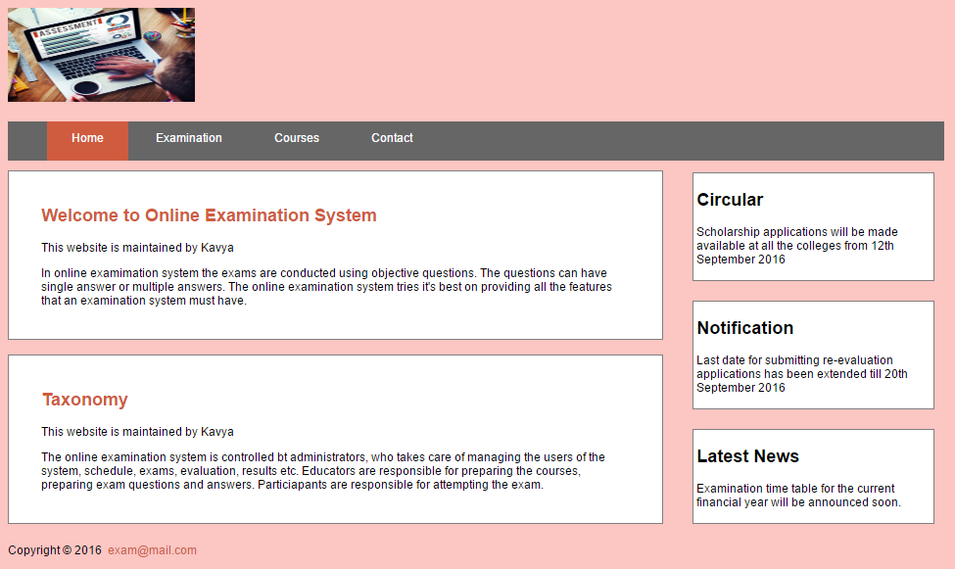

Hint: width, float, background-color, border, margin-left, padding, margin-bottom, margin-top properties
- Style the footer as shown below

Hint: Use width, height, float, background-color, border, margin, color, and font-size properties
- Style website-info as shown below



Hint: use font and color properties
- Style the registration form as shown in Fig 2
Hint: Use pseudo-classes
Duration: 180 minute
Marks Allocation:
- Styling the body and image – 5 marks
- Styling the navigation links - 10
- Styling the content - 3
- Styling the top and bottom content - 10
- Styling the sidebars -10
- Styling the footer – 5
- Styling the website-info - 2
- Styling the registration page - 5

